Opportunity > End of Quarter (JS Button)

UI

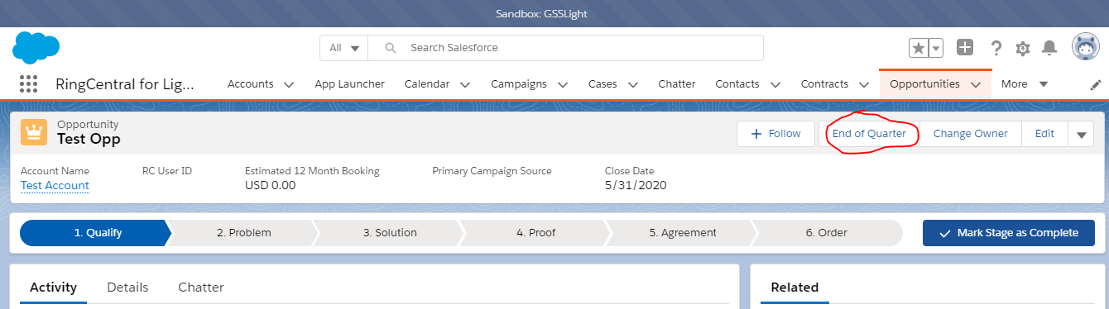

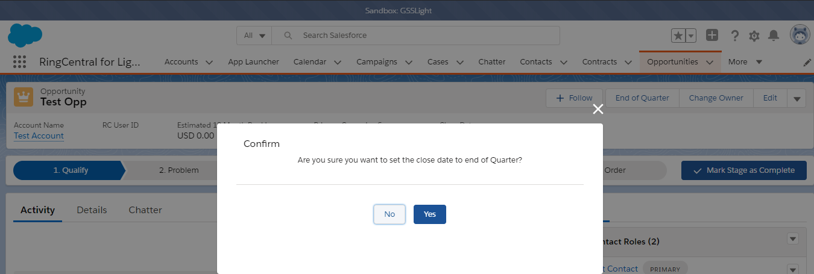

Component :

1. OpportunityLightningController (Class)
2. opportunityEndOfQuarte (Lightning Component-Aura)

Git Hub Link : <https://github.com/lipun038/RC_gsslight/tree/master/Aura/opportunityEndOfQuater>